Steps to add User setting.

1.Login to Sandbox, go to Set up and click on App launcher, Search for User settingds.
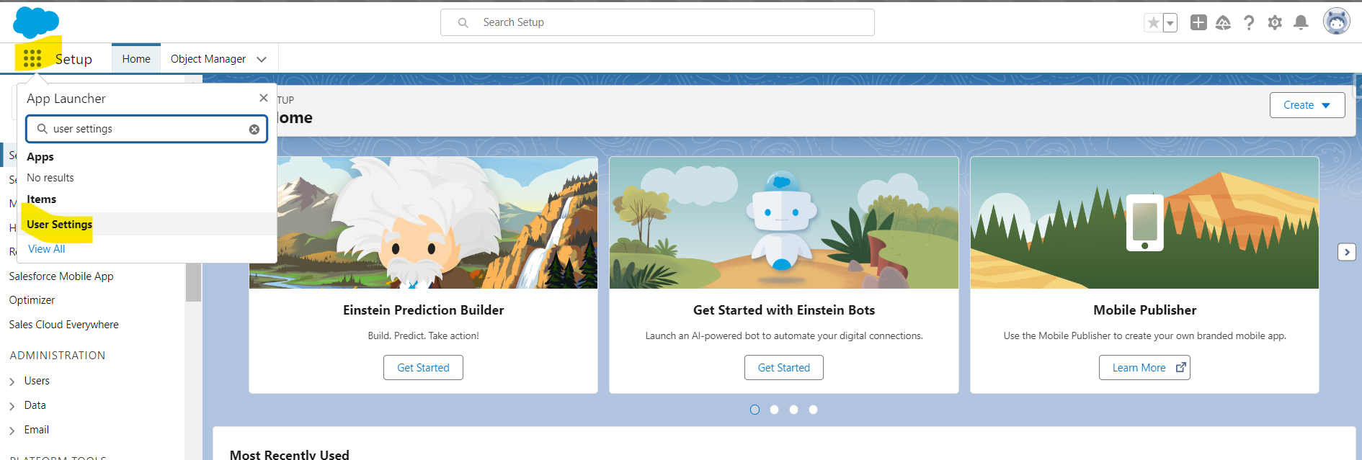
2. Click on User settings and open TPM_Processing Service.
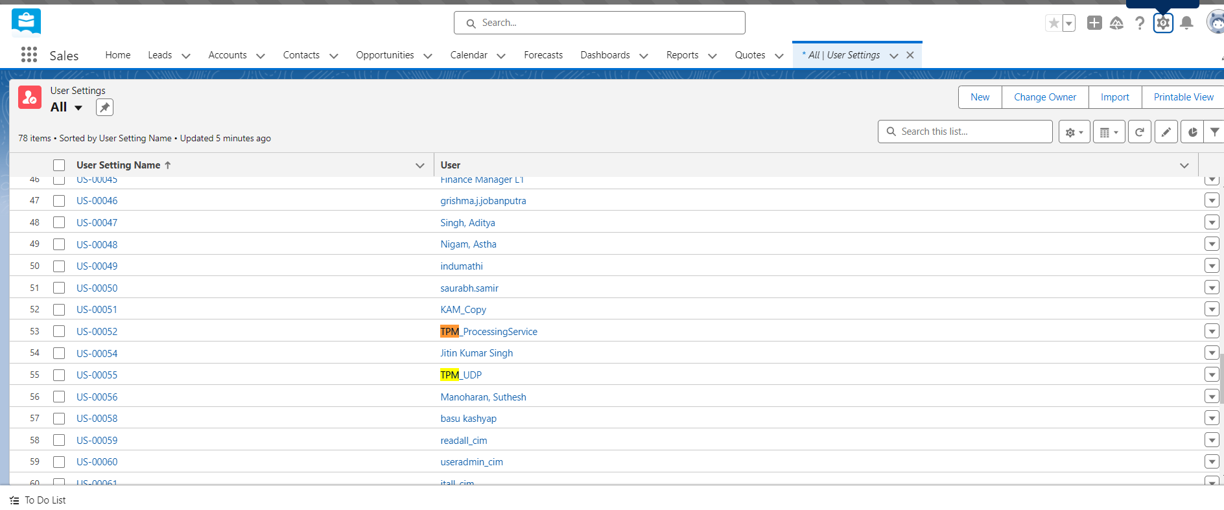
3. Add User and Role as mentioned below and click on Save,
a. User: TPM_Processing Service user.
b. CGT User Role: User Admin/Salesfoce-Admin.
